REINFORCEMENT LEARNING
4. DYNAMIC PROGRAMMING
4.1 Policy Evaluation (Prediction), Policy Improvement, Policy Iteration, Value Iteration, Asynchronous Dynamic Programming, Generalized Policy Iteration
PAST QUESTIONS:
- What are the methods used for policy evaluation? (M24)
- Explain the advantages and disadvantages of asynchronous updates in dynamic programming. (M24)
- What is the Bellman equation, and how does it relate to value iteration and policy iteration? (M25)
- Discuss the difference between on-policy and off-policy learning. Provide examples of algorithms that fall into each category. (M25)
- Compare between value iteration and Policy iteration? (M25)
- Explain Generalised policy iteration of policy evaluation and policy improvement? (M25)

NOTES:

*Methods for Policy Evaluation :-
Policy evaluation in reinforcement learning determines how good a policy is by estimating its value function using methods like Monte Carlo (full episode returns), Temporal Difference learning (bootstrapping on next states), and Dynamic Programming (model-based computation). These techniques compute expected returns to improve the agent's strategy.
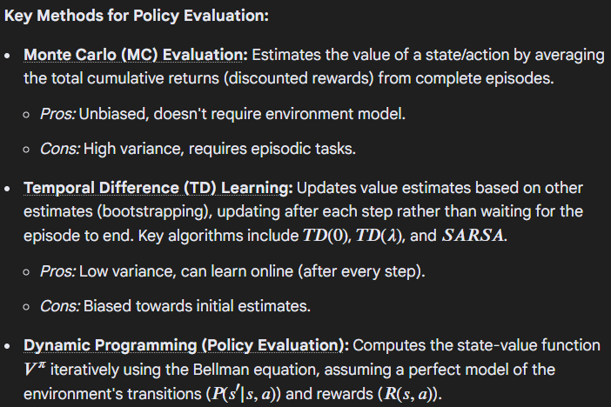
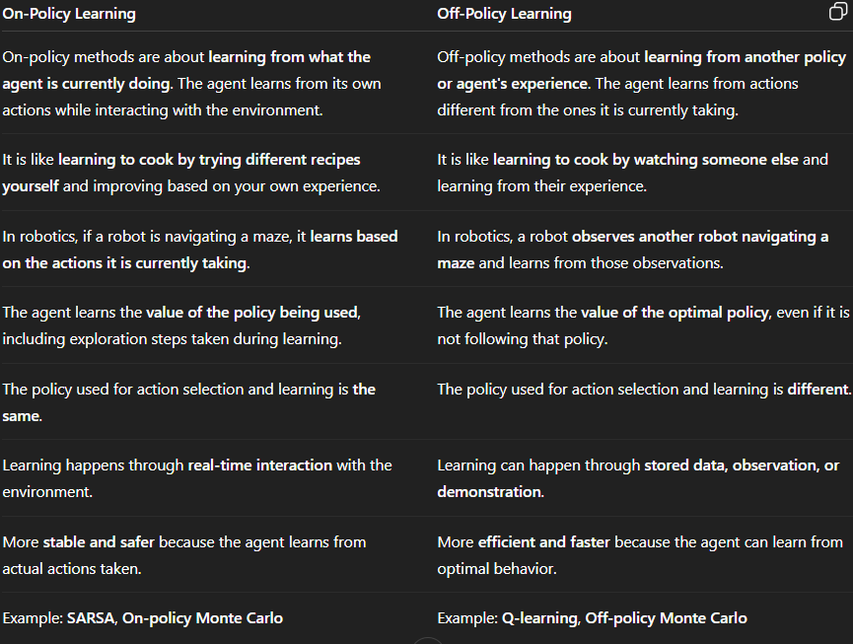
*Compare value iteration with policy iteration :-
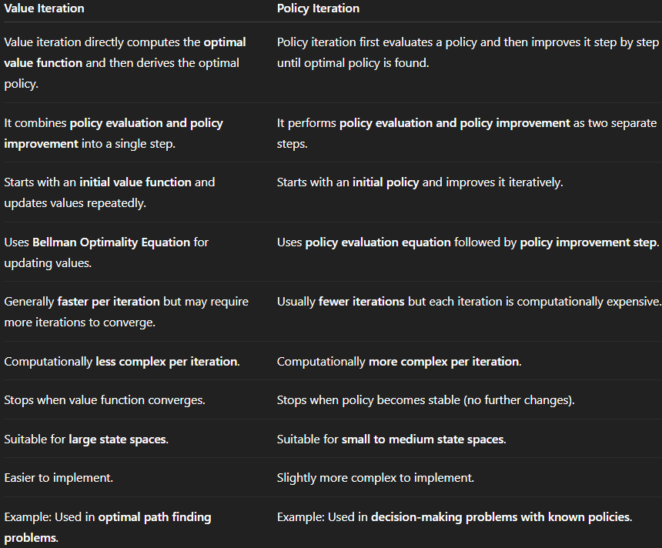

*Policy evaluation in Dynamic Programming :-
Dynamic Programming (DP) is a technique used to solve problems by breaking them down into smaller subproblems, solving each one and combining their results. In Reinforcement Learning (RL) it helps an agent to learn so that it acts in best way in an environment to earn the most reward over time.
In Reinforcement Learning dynamic programming is often used for policy evaluation, policy improvement and value iteration. The main goal is to optimize an agent's behavior over time based on a reward signal received from the environment.
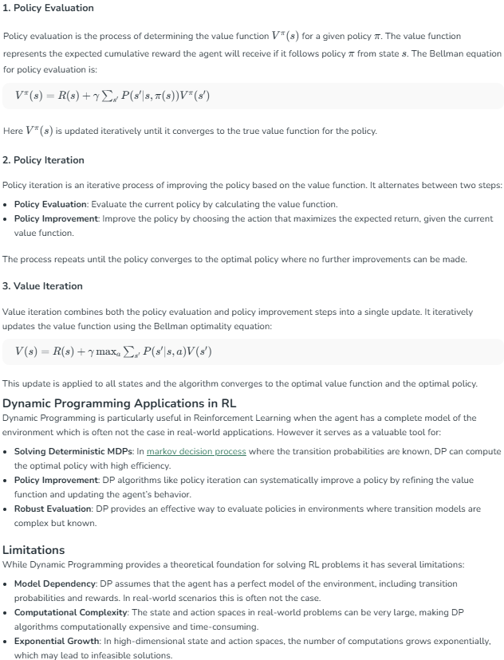
* Generalized Policy Iteration :-
Generalized Policy Iteration (GPI) is a foundational reinforcement learning concept describing the interaction between policy evaluation and policy improvement, where both processes run concurrently to find an optimal policy. It acts as a general framework for algorithms like Value Iteration and Policy Iteration, aiming for convergence by updating the policy to be greedy relative to the current value function.
Key Aspects of Generalized Policy Iteration
- Two Interacting Processes: GPI consists of policy evaluation (making the value function consistent with the current policy) and policy improvement (making the policy greedy with respect to the current value function).
- Interaction, Not Just Sequence: Unlike traditional policy iteration, where one process fully completes before the other begins, GPI permits them to interleave at various granularities.
- Convergence Goal: Both processes compete and cooperate, driving each other towards optimality. When both stabilize (neither can be updated further), the policy is optimal.

